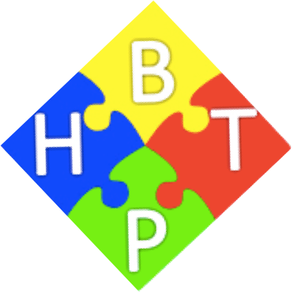
Maths at Breadsall Hill Top Primary School

Operational | Strategic
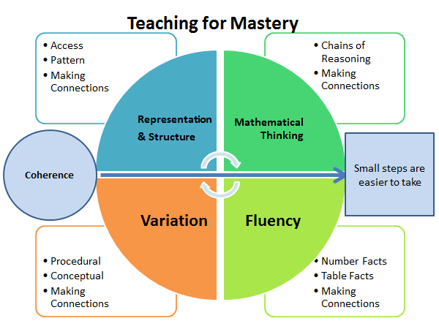 | Good maths mastery pedagogy underpins the intent behind the teaching of maths at BHTP to result in competent and confident learners.
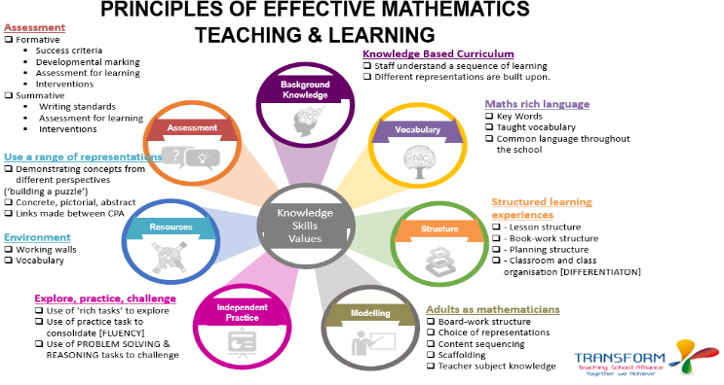 | Individual maths lessons at BHTP follow models of best practice e.g. Transform Fundamentals.
Theoretical Breadsall  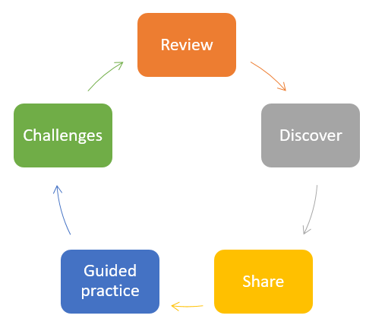  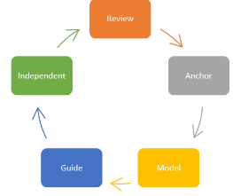 | Rosenshine - provides a model for individual lesson structure. The aim is to provide clarity for class teachers and reduce cognitive load for pupils.
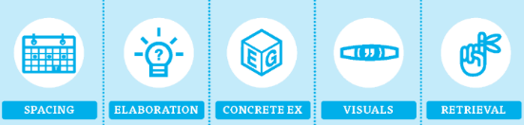 | Cognitive science supports ideas for activities within individual lessons.
  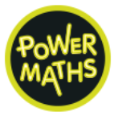    Power Maths can provide the initial structure to maths lessons. Magma Math is a digital platform that supports the use of Power Maths in school. | Maths lessons are appropriately sequenced over time. This will include how to develop children’s arithmetic skills to allow children to become mathematically fluent.
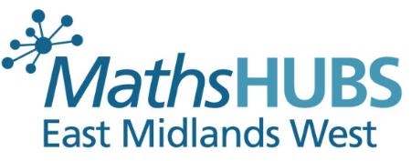  High quality CPD opportunities, calculation guidance  and teacher and leadership development. | Staff development – Subject and pedagogical knowledge.
BHTP & Transform Trust have systems in place to support the coaching model. It involves individual coaching sessions, planning and teaching support and lesson study facilitation. It is based on the above model that starts with the theory, which Trust Associates are able to provide before support to implement in to everyday practice and concludes with coaching to ensure that the teachers understand the level of impact an element of teaching has on the children’s learning. | Staff development – direct or indirect coaching depending on the support required.

